1. How to edit an already existing query in Power Query in excel?

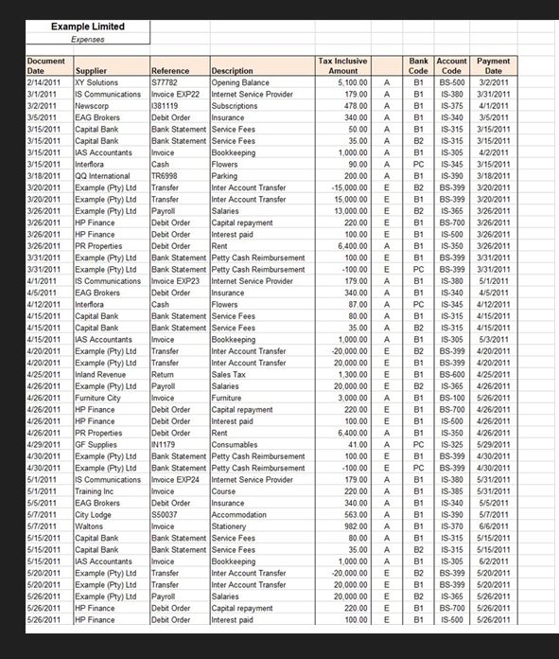

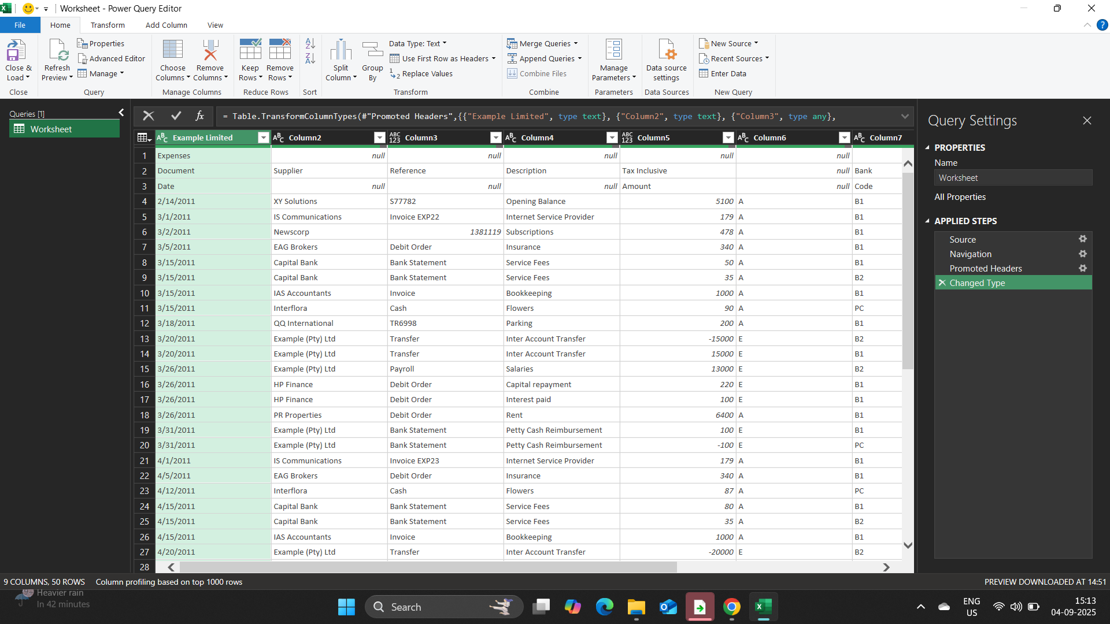

1. Open the Expenses sheet and note that one of the column headings is blank - we will not be able to create a pivot table which includes all the data on the Expenses sheet if one of the field names that need to be used in our pivot table is blank. Select cell F4 and enter the following heading for the column: Tax Code.

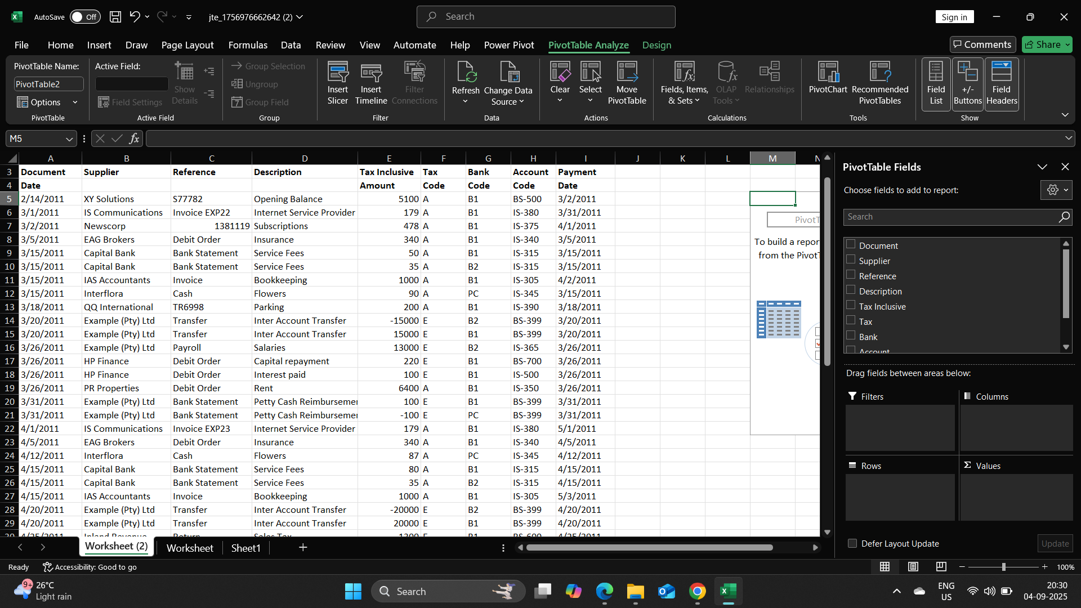

1. Filter the pivot table data with the slicer so that the supplier totals for only expenses that have been allocated to account IS-375 or account IS-390 are displayed in the pivot table.

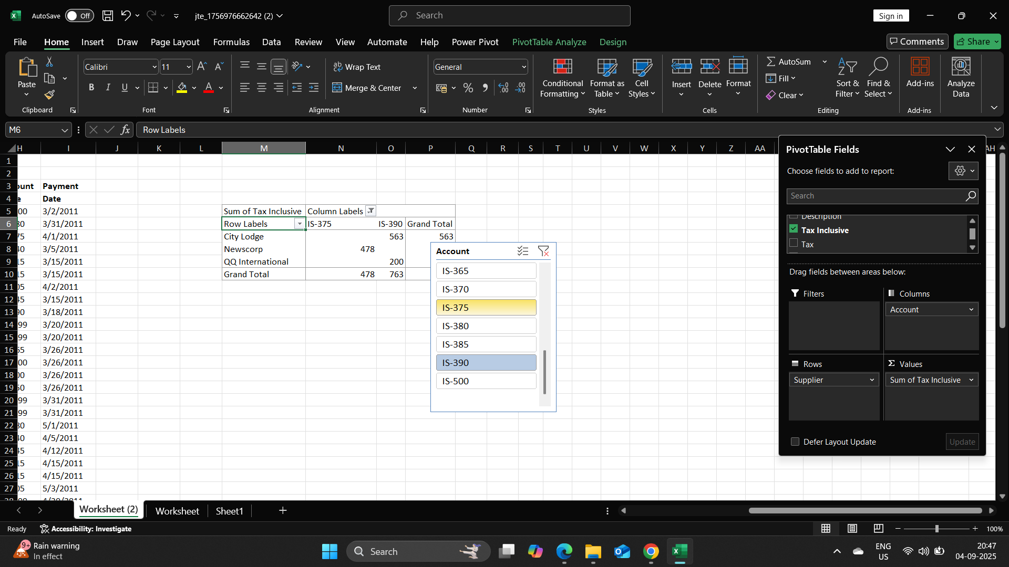

Question 2 : Replace Complex Excel Array Formulas with Simple Power Query Solution. 1) Goal is to extract a unique list of values from the Sales Rep Column, without using an Excel Array Formula.